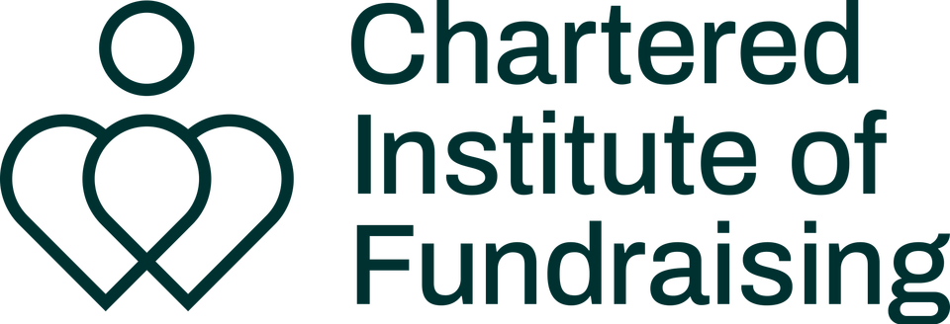
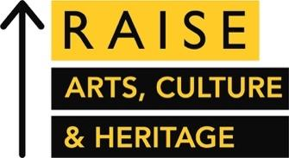
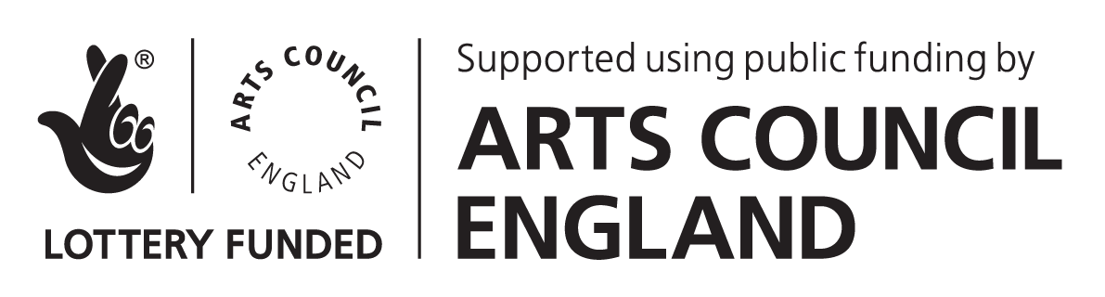

Guidance for Applicants
YAF x RAISE Evolve Programme | 2023-24
Application deadline: Sunday 25th June 2023
IF YOU:
- Are raising money for arts and culture projects or organisations

- Are looking for advice and guidance on how to progress as an arts fundraiser.

- Have clear career goals but need help figuring out how to achieve them
- Want to build confidence in specific areas of fundraising or your professional life.
- Need a sounding board to work through ideas or challenges

- Are a sole fundraiser, work in a small team and/or lack a peer-support network

Then Evolve might be for you!
Hear what former YAF Mentees have to say
Take a listen to audio interviews with past participants of our mentoring programme (now incorporated into Evolve) to understand more about how you could benefit:
Interview with Rosie Gitsham, Fundraising Assistant at Libraries Unlimited, 2020-21 Cohort
Interview with Maisie Pearson, Development Officer at York Theatre Royal, 2020-21 Cohort

WHAT IS THE YAF x RAISE EVOLVE PROGRAMME?
Evolve is a year-long professional development programme that aims to equip early-career arts fundraisers with the advice, networks and peer support that they need to succeed.
Having grown rapidly since its inception as a pilot mentoring scheme in 2016, Evolve is run by Young Arts Fundraisers (YAF) in partnership with the Chartered Institute of Fundraising Cultural Sector Network (CSN) and is funded by Arts Council England as part of CIOF’s RAISE: Arts, Culture and Heritage programme.
The Evolve Programme:

- Matches early career fundraisers in the arts and culture sector with senior or director level development professionals from a wide range of cultural organisations across England for 6 1-2-1 mentoring sessions.

- Pairs selected participants together as ‘buddies’ to build long-term mutually supportive relationships amongst peers.

- Facilitates 6 sessions of peer-to-peer learning and networking amongst the cohort, using action learning and coaching methodologies. Invited speakers and workshop leaders may sometimes run these sessions. Participants will work together to design and set the agenda for each session.

- Spotlights cohort participants’ work and careers via blog posts, articles and interviews that are distributed via YAF’s newsletter, social media and LinkedIn.

- Supports programme alumni with further advice and networking opportunities such as connecting alumni with the CIOF or inviting them to become speakers at YAF events.

WHO CAN APPLY? ELIGIBILITY CRITERIA
You just need to:
- Be raising money for arts and culture and demonstrate a commitment to continuing in this field. Participants have come from a range of roles in the arts, including independent artists and freelance producers, as well as those working directly within fundraising and development teams.
- Have your line manager’s agreement to take part. It’s important that they fully support you to engage with all aspects of the programme, including attending the peer-to-peer sessions which take place in working hours.

You don’t need to:

- Call yourself a fundraiser. Evolve is for anyone who is raising money in the arts. Your work doesn’t need to be exclusively focussed on fundraising to apply, and your job title doesn’t have to reflect your fundraising work either. You might not have even considered yourself a fundraiser until reading this call out, and that’s okay too.
- Be working full-time or have been paid for your fundraising work. We recognise the valuable contribution that freelancers, contract workers, volunteers and independents make to the sector.

- Be ‘young’. Whilst we’re called ‘Young’ Arts Fundraisers, your age isn’t important. We’re all about supporting arts fundraisers in the early stages of their career, whenever that might be. You may have recently graduated or you could have had a previous career in another industry and just made the jump into arts fundraising.
PARTICIPANT COMMITMENTS
As a participant on Evolve, you will be expected to:
- Complete and sign our Evolve Programme Agreement Form.
- Initiate and organise a minimum of 6 meetings with your mentor to work on your professional development goals. Participants will be expected to set the agenda for these sessions.
- Attend 6 peer-to-peer sessions with the full cohort and actively contribute towards cohort activities, including deciding how to structure this time. Please note: these sessions take place on Zoom from 9.30am to 11am on Wednesdays every two months and attendance is mandatory.
- Meet with your buddy 1-2-1 at least 6 times during the year, at times to be mutually agreed between yourselves.
- Complete all required evaluation for the programme, including a 3-month 1-2-1 Zoom call with a member of the YAF team, and mid and end of programme surveys.
EVOLVE PROGRAMME DATES
Participants are expected to adhere to the below schedule, including attending all peer-to-peer sessions which take place on Zoom.
Sunday 25th June 2023 | Deadline for applications
w/c 3rd July 2023 | All applicants notified of outcome
Friday 14th July 2023 | Deadline to accept place on Evolve
By end of July 2023 | Welcome documentation provided to cohort, and introductions made between buddy and mentor/mentee pairings
9.30am - 11am, Wednesday 6th September 2023 | Introductory peer-to-peer session
9.30am - 11am, Wednesday 1st November 2023 | Peer-to-peer session 2
w/c 4th December 2023 | Participants attend 20-minute 1-2-1 Zoom check in calls with the YAF team.
9.30am - 11am, Wednesday 10th January 2024 | Peer-to-peer session 3
w/c 5th February 2023 | Participants complete mid-programme evaluation survey
9.30am - 11am, Wednesday 6th March 2024 | Peer-to-peer session 4
9.30am - 11am, Wednesday 1st May 2024 | Peer-to-peer session 5
9.30am - 11am, Wednesday 26th June 2024 | Peer-to-peer session 6
w/c 24th June 2024 | Participants complete end-of-programme evaluation survey
HOW TO APPLY
The deadline for applications is Sunday 25th June 2023.
Applications must be submitted via this form. Answers to the application questions may be submitted in a written, video or audio format. A word document of the application questions can be downloaded from the website.
Successful applicants typically demonstrate a strong understanding of the purpose of all elements of the programme and identify specific outcomes that they hope to achieve.
If you’d like to discuss submitting your application in an alternative format, or have other questions about the programme, then please get in touch with Hannah Tookey, Head of Mentoring at mentoring@youngartsfundraisers.org.
HOW IS MY APPLICATION ASSESSED?
After removing applicant names, all applications are read by at least two members of the YAF x RAISE team and scored on a sliding scale.
YAF is committed to tackling barriers to progression in arts fundraising and supporting a diverse cohort. As such, we use weighted scoring to prioritise applicants to whom the following criteria is applicable:
- Anyone identifying as a person of the Global Majority
- Anyone identifying as disabled and or D/deaf, including those who are neurodiverse or have a long-term health condition
- Anyone identifying as LGBTQ+
- Anyone self-identifying as early-career arts, cultural & heritage sector fundraisers and/or anyone who is in the first five years of their fundraising career
- Small and medium charities: Organisations with an annual turnover (contributed and earned income) up to £750,000.
- Anyone who is based regionally or work for a regional (non-London) organisation
It’s important that we find the right match between mentees and mentors, so availability of mentors will also factor into the panel’s decision.
Feedback will be available to all unsuccessful applicants if requested. YAF is a volunteer-led organisation so it might take a little time to provide this, but we’ll endeavour to do so as quickly as possible.

