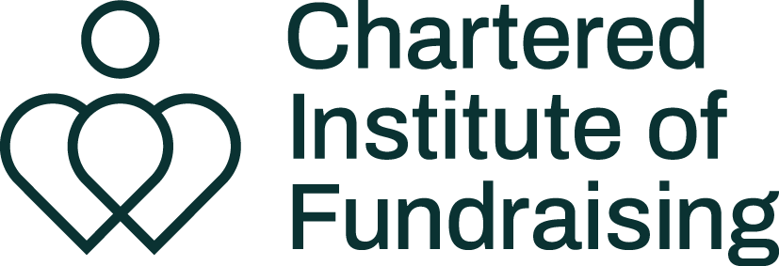

Photography brief template

 | Things to think about
Date of shoot: | If you will be using your photos at another time of year, you might want to make sure seasonal markers are not included in shots, for example snow in photos that will be used in the summer.
Location: | If you’re in a public or private space you may need permission from the Council, land owner etc.  Who else might be there? If it’s a public space, how will you ensure you don’t breach privacy?  Is the location accessible for everyone taking part?  If it is outside, what is the weather forecast and what’s the plan if the weather isn’t what you expected?
Arrival time: | Will everyone be arriving at the same time or do you or the photographer need time to set up first?  Will there be natural light or is additional lighting required? Consider the time of day and how it might impact the lighting.
Finish time: | Do you have a set finish time or will you keep going until you have everything you need? If you have young people participating that might impact how long you can work with them for.
Staff / chaperones present: | Which members of your team will be present, have they been briefed fully and can they deal with any issues that arise?  Chaperones are vital when working with anyone under aged 18, vulnerable people or if there are sensitivities with the subject matter etc.
Models / participants and props: | Who are they, what is their story? How many of them are there, what age are they? What props will be available?
Budget: | Your budget might impact how much time the photographer will be available on the shoot day, or how much time they spend editing.
Project overview: | An overview of the project as a whole so the photographer can see how the photos fit into the campaign.
Purpose of the photoshoot: | Give the photographer an idea of what the key aims of the photoshoot are. What is the story that you want the photos to tell?
What the photos will be used for: | Consider all the ways that the photos will be used, so the photographer can make sure you get what you need. You might get a range of different photos if you plan on using them on social, in corporate documents, on your website, etc. If you will be laying text over the image let the photographer know.
Types of shot required: | Landscape, portrait, close up, wide angle, details, product shots, expressive shots etc.
Shot list: | If you have specific shots you need the photographer to capture.
Tone / style / inspiration: | Do you want the photos to be serious, funny, light-hearted, corporate, posed, reportage, natural etc. Share your brand guidelines if you have them.
When you need the photos delivered by: | The photographer will need time to process and edit a selection of photos.
How many photos you need: | Having a variety of photos is likely to be more useful than having just a few.
How you want the photos delivered: | USB, via email, transfer sites etc
Edits needed: | If you need crops, colours editing, items removed from the back of shots, brands removed etc.
Consent forms: | Who will be responsible for organising, recording and storing consent forms from participants?
Any other useful information: | Anything else that might be useful for your photographer to know.

Created by the Chartered Institute of Fundraising, June 2024
If you have found this template helpful, you might be interested in the other
guidance and resources we have available just for members.
Find out more about membership.

