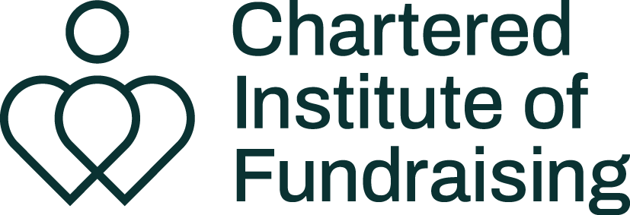

Creative brief template

Date
Contact details
Campaign name

 | Things to think about
Campaign overview | What is the campaign and how does this artwork fit in to it?
Outputs | What you actually need, for example x3 Instagram graphics, 2 x website banner images and 1 x infographic
Dimensions | Provide dimensions for the outputs that you need.
Target audience | You might need different versions of the same content if you are using it across multiple channels and multiple audiences
Tone | Will it be serious, instructional, informative, engaging, professional, humorous, etc?
Required elements | What has to be included in the designs?
Call to action | What is the one thing you want people to do?
Branding | Share your brand guidelines, and those of any partners you’re working with. Which logos need to be included, what is your brand font, etc?
Budget | Your budget might impact how long the designer spends on your artwork, or how many rounds of amends you will be able to do.
Timings | When do you need to see a first draft, how long will it take you to collate feedback and share it with the designer? What’s the deadline for receiving the final artwork?
Supporting documents | Provide a word document with any copy and instructions to the designer. Ideally this will be copy that has been signed off so that you are making only a few amends to the copy when you see it in the artwork.
Other useful information | Anything else the designer should know.

Created by the Chartered Institute of Fundraising, June 2024
If you have found this template helpful, you might be interested in the other
guidance and resources we have available just for members.
Find out more about membership.

