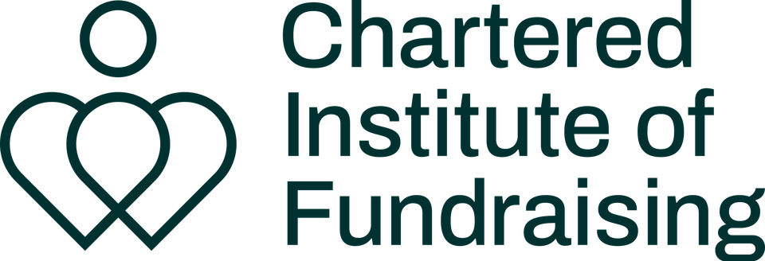
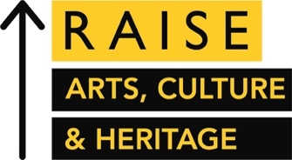
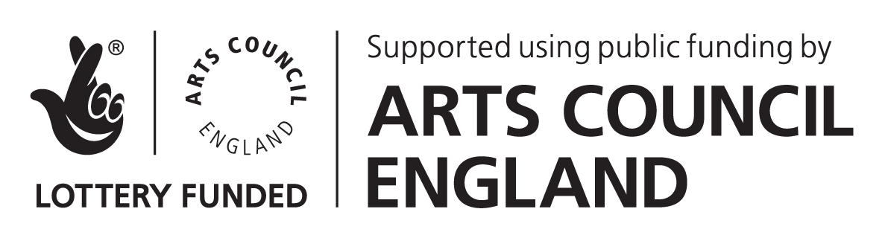
Guidance for Applicants
YAF x RAISE Evolve Programme | 2022-23
Application deadline: Sunday 26th June 2022

Link to Application form
WHAT IS THE YAF x RAISE EVOLVE PROGRAMME?
Young Arts Fundraisers (YAF) and RAISE are pleased to open the call for applications for Evolve, our annual year-long professional development programme that aims to equip early-career arts fundraisers with the advice, networks and peer support that they need to succeed.

Having grown rapidly since its inception as a pilot mentoring scheme in 2016, Evolve is run in partnership with the Chartered Institute of Fundraising Cultural Sector Network (CSN) and is funded by Arts Council England as part of CIOF’s RAISE: Arts, Culture and Heritage programme. Thanks to the funding from Arts Council England, and to the volunteers at YAF and CSN, we are pleased to offer free places to the participants on this programme.

The long term aim of the Evolve Programme is to build capacity within the arts fundraising sector and to encourage early career talent, focusing on expanding the skillset of early career arts fundraisers and growing confidence.

There are 20 spaces on the Evolve Programme, which enables us to tailor the programme to specific professional development needs of the participants.
The Evolve Programme:

- Matches early career fundraisers in the arts and culture sector with senior or director level development professionals from a wide range of cultural organisations across England for six 1-2-1 mentoring sessions.

- Pairs selected participants together as ‘buddies’ to build long-term mutually supportive relationships amongst peers.

- Facilitates six sessions of peer-to-peer learning and networking amongst the cohort, using action learning and coaching methodologies. Invited speakers and workshop leaders may sometimes run these sessions. Participants will work together to design and set the agenda for each session.

- Offers ad-hoc speed mentoring opportunities to participants throughout the year.

- Spotlights cohort participants’ work and careers via blog posts, articles and interviews that are distributed via YAF’s newsletter, social media and LinkedIn.

- Supports programme alumni with further advice and networking opportunities such as connecting alumni with the CIOF or inviting them to become speakers at YAF events.
Evolve might be a good fit for you, if you:
- Are looking for advice and guidance on how to progress your arts fundraising career.
- Have clearly identified career goals but need help figuring out how to achieve them.
- Want to build confidence in specific areas of fundraising or your professional life.
- Are in need of a sounding board to work through ideas or problems you’re facing.
- Are a sole fundraiser, freelancer, or work in a small team and lack a peer-support network.
Still unsure? Take a listen to podcast interviews with past participants of our mentoring programme (now incorporated into Evolve) to understand more about how you could benefit from being part of Evolve:
Interview with Rosie Gitsham, Fundraising Assistant at Libraries Unlimited, 2020-21 Cohort
Interview with Maisie Pearson, Development Officer at York Theatre Royal, 2020-21 Cohort
WHO ARE YOUNG ARTS FUNDRAISERS?
We’re a volunteer and peer-led professional network for early career fundraisers in the cultural sector, seeking to connect, engage and mentor our members. We believe that long term financial resilience and sustainability in the sector can be achieved by equipping early-career fundraisers with appropriate skills and support networks. We hold monthly events, including panel discussions with sector leaders, skills workshops, networking opportunities and speed mentoring.
WHO ARE THE MENTORS?

All of the mentors on the scheme are senior fundraisers, with significant management experience. Most of them have participated in the scheme for at least one year previously. They work for a range of cultural organisations across England, representing a broad range of artforms. Recent mentors include fundraising leaders from Lichfield Cathedral, National Trust, English National Opera, National Theatre and the Science Museum Group.

WHO CAN APPLY? ELIGIBILITY CRITERIA
Evolve is for anyone who is raising money in the arts. Your work doesn’t need to be exclusively focussed on fundraising to apply, and your job title doesn’t necessarily have to reflect your fundraising work either. You might not have even considered yourself a fundraiser until reading this call out, and that’s okay too.
Participants have come from a range of roles in the arts, including independent artists and freelance producers, as well as those working directly within fundraising and development teams. Fundraising should be an important part of your work, but it doesn’t have to be all that you do. You could be working full or part time, on a paid or volunteer basis, as long as you can demonstrate experience of and a commitment to fundraising for arts and culture.
Whilst we’re called ‘Young’ Arts Fundraisers, your age isn’t important to us. We’re all about supporting arts fundraisers in the early stages of their career, whenever that might be. You may have recently graduated and be starting out in arts fundraising, or you could have had a previous career in another industry or area of the sector and have just made the jump into fundraising.
You must meet the following key eligibility criteria to apply:
- Be an arts fundraiser and be able to demonstrate a commitment to continuing in this field
- Be based/work for an organisation in England (as the scheme is funded by Arts Council England)
- Have received the agreement of your line manager (if applicable i.e. if employed) to engage with all aspects of the programme, including attending all six peer-to-peer sessions (which take place during working hours).
Young Arts Fundraisers is committed to tackling barriers to progression in arts fundraising and supporting a diverse cohort. As such, we prioritise applicants to whom the following criteria is applicable:
- Anyone identifying as a person of the Global Majority
- Anyone identifying as disabled and or D/deaf, including those who are neurodiverse or have a long-term health condition
- Anyone identifying as LGBTQ+
- Anyone self-identifying as early-career arts, cultural & heritage sector fundraisers and/or anyone who is in the first five years of their fundraising career
- Small and medium charities: Organisations with an annual turnover (contributed and earned income) up to £750,000.
- Anyone who is based regionally or work for a regional (non-London) organisation
PARTICIPANT COMMITMENTS
As a participant on Evolve, you will be expected to:
- Complete and sign our Evolve Programme Agreement Form.
- Initiate and organise a minimum of six meetings with your mentor to work on your professional development goals. Participants will be expected to set the agenda for these sessions. The sessions can take place online or in person.
- Attend six peer-to-peer sessions with the full cohort and actively contribute towards cohort activities, including deciding how to structure this time. Please note: these sessions take place on Zoom from 9.30am to 11am on Wednesdays every two months and attendance is mandatory.
- Meet with your buddy 1-2-1 online or in person at least six times during the year, at times to be mutually agreed between yourselves.

- Complete all required evaluation for the programme, including a 3-month 1-2-1 Zoom call with a member of the YAF team, and mid and end of programme surveys.
EVOLVE PROGRAMME DATES
Monday 16th May 2022 | Call for applications opens
Sunday 26th June 2022 | Deadline for applications
w/c 11th July 2022 | All applicants notified of outcome
9.30am - 11am, Wednesday 7th September 2022 | Introductory peer-to-peer session
9.30am - 11am, Wednesday 1st November 2022 | Second peer-to-peer session
w/c 5th December 2022 | Participants attend 20-minute 1-2-1 Zoom check in calls with the YAF team.
9.30am - 11am, Wednesday 11th January 2023 | Third peer-to-peer session
w/c 6th February 2023 | Participants complete mid-programme evaluation survey
9.30am - 11am, Wednesday 1st March 2023 | Fourth peer-to-peer session
9.30am - 11am, Wednesday 3rd May 2023 | Fifth peer-to-peer session
9.30am - 11am, Wednesday 28th June 2023 | Final peer-to-peer session
w/c 26th June 2023 | Participants complete end of programme evaluation survey
HOW TO APPLY
The deadline for applications is Sunday 26th June 2022.
Applications must be submitted via this form. Answers to the application questions may be submitted in a written, video or audio format. A word document of the application questions can be downloaded from the website.
Word limits are a suggestion and we haven’t included limits in the form to save applicants the time spent cutting their answers to fit the box. It’s fine if yours are a under or a little over, but please don’t exceed this excessively.
Successful applicants typically demonstrate a strong understanding of the purpose of all elements of the programme and identify specific outcomes that they hope to achieve.
If you’d like to discuss submitting your application in an alternative format, or have other questions about the programme, then please get in touch with Hannah Tookey, Head of Mentoring at mentoring@youngartsfundraisers.org.
HOW IS MY APPLICATION ASSESSED?
After removing applicant names, all applications are read by at least two members of the YAF/RAISE/CIoF CSN team and scored on a sliding scale. Additional weighting is added to each application that matches our priority criteria outlined above.
It’s important that we find the right match between mentees and mentors, so availability of mentors will also play a role in deciding who is selected for the programme. We also take the balance between applicant’s art forms and fundraising specialisms into account.
Feedback will be available to all unsuccessful applicants if requested. YAF is a volunteer-led organisation so it might take a little time to provide this, but we’ll endeavour to do so as quickly as possible.

